E6
Even more specialities for even more enjoyment
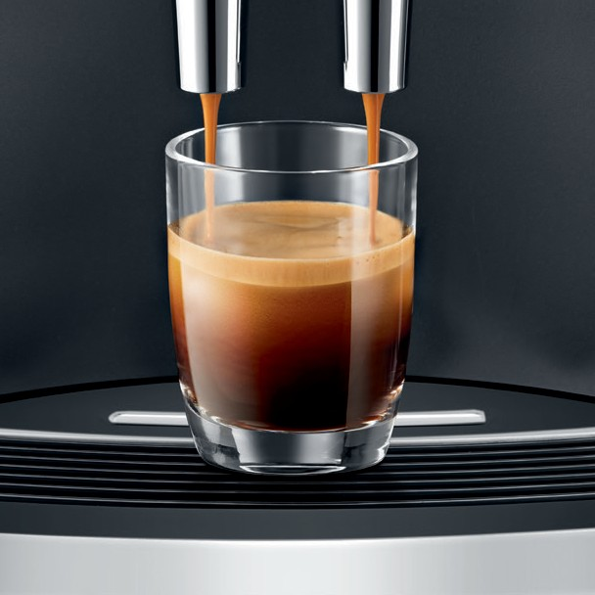
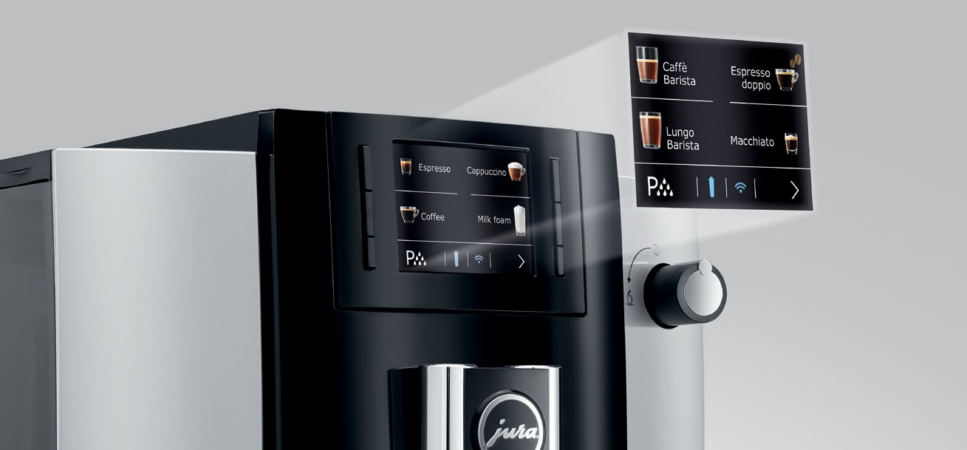
The new E6 perfectly combines variety with outstanding aesthetic appeal. Alongside coffee classics and speciality coffees finished with milk foam, the E6 model now also boasts four additional highlights: caffè Barista, lungo Barista, espresso doppio and macchiato.
The Pulse Extraction Process (P.E.P.®) optimises the extraction time and guarantees the very best aroma even for short speciality coffees.
Benefits at a glance
- An additional product page extends the selection to a total of 11 different specialities
- AromaG3 grinder and Pulse Extrac- tion Process (P.E.P.®) for ultimate coffee quality
- Operating concept with controls on front of machine, with a 2.8“ TFT colour display and a water tank filled from the front
- CLARIS Smart supplies perfect water quality and is automatically recognised by the I.W.S.®
The premium, chrome-plated cup grille serves as the perfect stage to showcase each and every speciality.

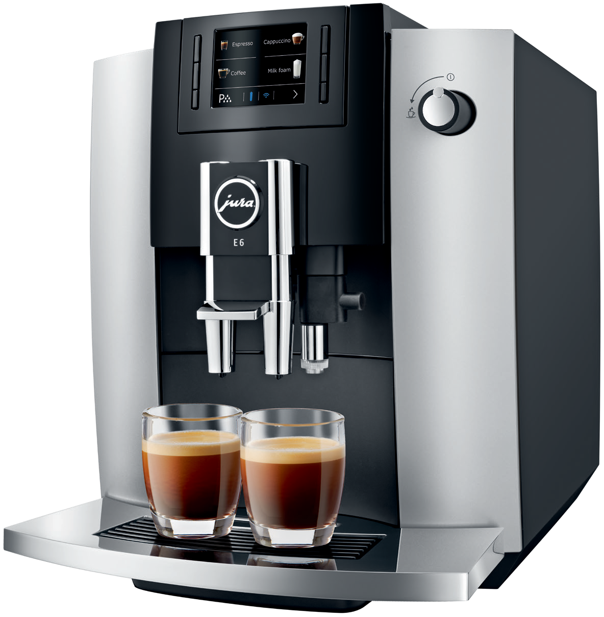

E6  Technical data  Specific advantages  No. of individually programmable specialities |  | 11 |  | Design and materials  Display |  | Colour display
Intelligent preheating |  | ¡
Intelligent Water System (I.W.S.®) |  | ¡ |  | In figures
Compatible with J.O.E.® |  | ¡ |  | Height-adjustable coffee spout |  | 65 – 111 mm
Wireless ready |  | ¡ |  | Height-adjustable hot-water spout |  | 65 – 111 mm
Monitored drip tray |  | ¡ |  | Water tank capacity |  | 1,9 l
Aroma preservation cover |  | ¡ |  | Bean container holding capacity |  | 280 g
 |  |  |  | Coffee grounds container (servings) |  | ca. 16
JURA standards |  |  |  | Cable length |  | ca. 1,1 m
Pulse Extraction Process (P.E.P.®) |  | ¡ |  | Voltage / Power |  | 230 V ~ / 1450W
Variable VC brewing unit, from 5 g to 16 g |  | ¡ |  | Current |  | 10 A
Intelligent Pre-Brew Aroma System (I.P.B.A.S.©) |  | ¡ |  | Stand-by power |  | 0 W
Grinder |  | Multi-level |  | Weight |  | 9,8 kg
 |  | Aroma G3 grinder |  | Dimensions (W × H × D) |  | 28 × 34,6 × 44,4 cm
High-performance pump, 15 bar |  | 1 |  | Colour |  | Platinum
Thermoblock heating system |  | 1
Fluid systems 1
Hygiene standards
CERTIFIED

JURA fine foam technology ¡

Milk system HP1

Maintenance status display ¡

Integrated rinsing, cleaning and descaling pro- ¡
gramme

Integrated milk system rinsing and cleaning pro- gramme ¡

JURA hygiene: TÜV-certified ¡

CLARIS filter cartridge CLARIS Smart

Energy Save Mode (E.S.M.©) ¡

Zero-Energy Switch or power switch ¡

Settings and programming options

Programmable and individually adjustable amount of water
Programmable and individually adjustable coffee strength

¡

8 levels

201908 – JURA reserves the right to modify specifications without notice. spiceadvertising
Programmable brewing temperature 2 levels

Programmable amount of milk / milk foam ¡

Programmable temperature of hot water 3 levels

Programmable switch-off time ¡

JURA – If you love coffee

